Wandering in the Woods Game: Agile Project Documentation

Rachael Morrison, Benjamin Ayirifa, Shivasai Priyatham Kota, and Siva Prasad Polisetty

College of Aviation, Science, and Technology, Lewis University

FA22-CPSC-60500-004 Software Engineering

Dr. Fadi I. Wedyan

December 14, 2022

***ALL INFORMATION IS CURRENTLY FROM TEMPLATE FOR A DIFFERENT PROGRAM**

Table of Contents

1.0 Introduction 2

1.1 Purpose 2

1.2 Description 2

2.0 Process Model

3.0 Use Cases

3.1 Use Case 1:

3.2 Use Case 2:

3.3 Use Case 3:

3.4 Use Case 4:

3.5 Use Case 5:

3.6 Use case 6:

4.0 UML Model

4.1 Use Case Diagram

4.2 Class Diagram

4.3 Activity Diagram

5.0 Personas

6.0 UI Mock-up

7.0 User Guide

7.1 Teachers

7.2 Students

# Introduction

## Purpose

## Description

# Process Model

The software development team will use the evolutionary process model as show in Figure 1. The model the team selected is based on the desire to allow for rapid prototyping and iteration of design. The model is based on agile and spiral model principals in order to encapsulate feedback and risk management in to the decisions making for continuous evolution of the game.

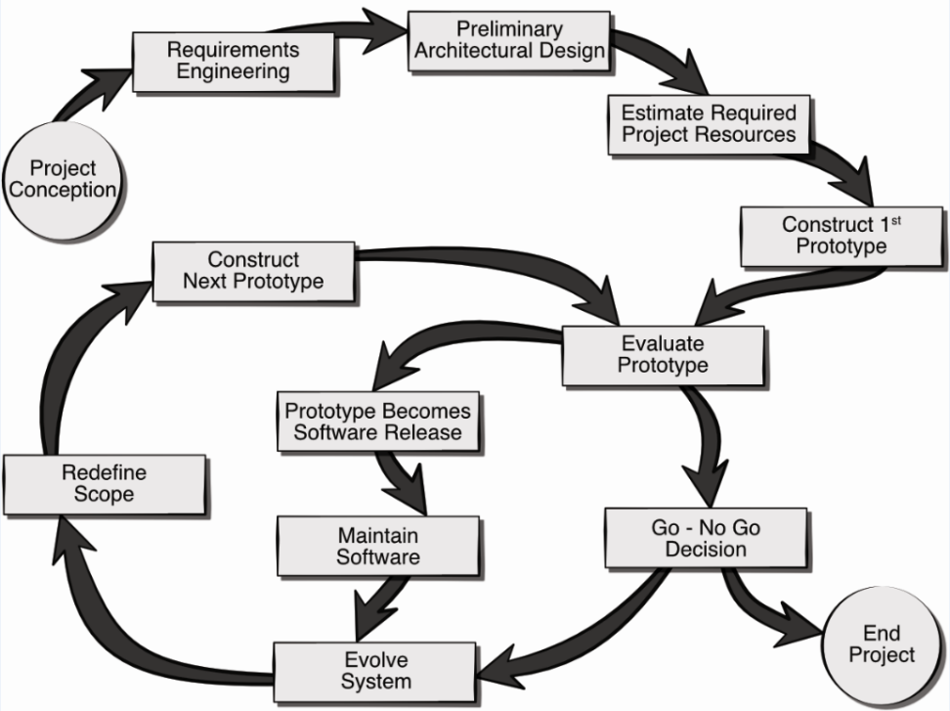



# Use Cases

The following uses cases were defined by the team as the core system requirements for the delivery of working prototype. Note, this baseline functionality can be easily extended through the inclusion of more use cases as the project progresses. Each use case lists the name of the use case, primary actors, preconditions, description, and acceptance criteria.

## Use Case 1:

**Primary Actor:**

**Preconditions:**

**Description:**

**Acceptance Criteria:**

## Use Case 2:

**Primary Actor:**

**Preconditions:**

**Description:**

**Acceptance Criteria:**

## Use Case 3:

**Primary Actor:**

**Preconditions:**

**Description:**

**Acceptance Criteria:**

## Use Case 4:

**Primary Actor:**

**Preconditions:**

**Description:**

**Acceptance Criteria:**

## Use Case 5:

**Primary Actor:**

**Preconditions:**

**Description:**

**Acceptance Criteria:**

## Use case 6:

**Primary Actor:**

**Preconditions:**

**Description:**

**Acceptance Criteria:**

# UML Model

## Use Case Diagram

The six use cases are included in the use case diagram as seen in Figure 2.

*** Figure 2 goes here ***

## Class Diagram

The class diagram for the core system of the Wandering in the Woods game is depicted in Figure 4. The classes in the diagram are described below the figure.

*** Figure 4 goes here ***

*** Class descriptions go here ***

## Activity Diagram

The activity diagram shown in Figure 5 presents a more detailed description of the high-level behavior of the Wandering in the Woods game.

*** Figure 5 goes here ***

# Personas

Figure 6 and figure 7 show two representative samples of a personas for the Wandering in the Woods game.

*** Figure 6 TEACHER ***

*** Figure 7 STUDENT ***

# UI Mock-up

The user interface mock-up for the Wandering in the Woods game is presented in Figure 8.

*** Figure 8 ***

# User Guide

## Teachers

## Students